CO1 -AT3 OUTPUT PREDICTION

1.MISSING NUMBER
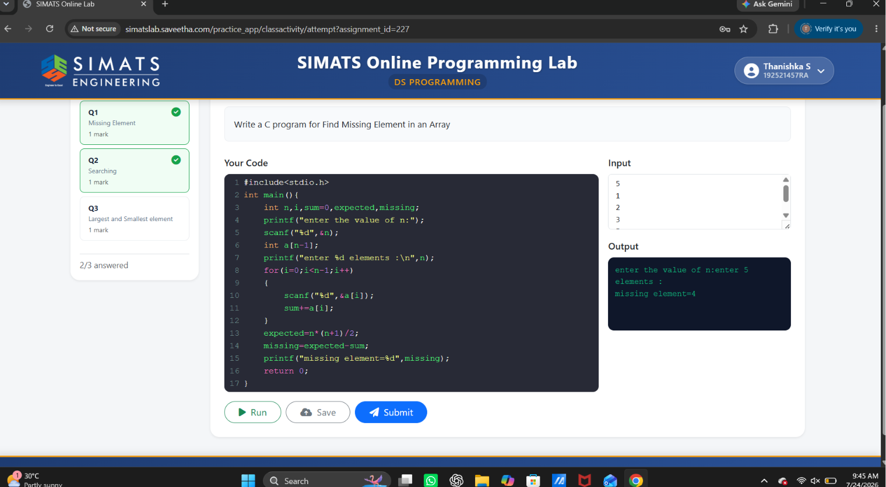

2.SEARCHING
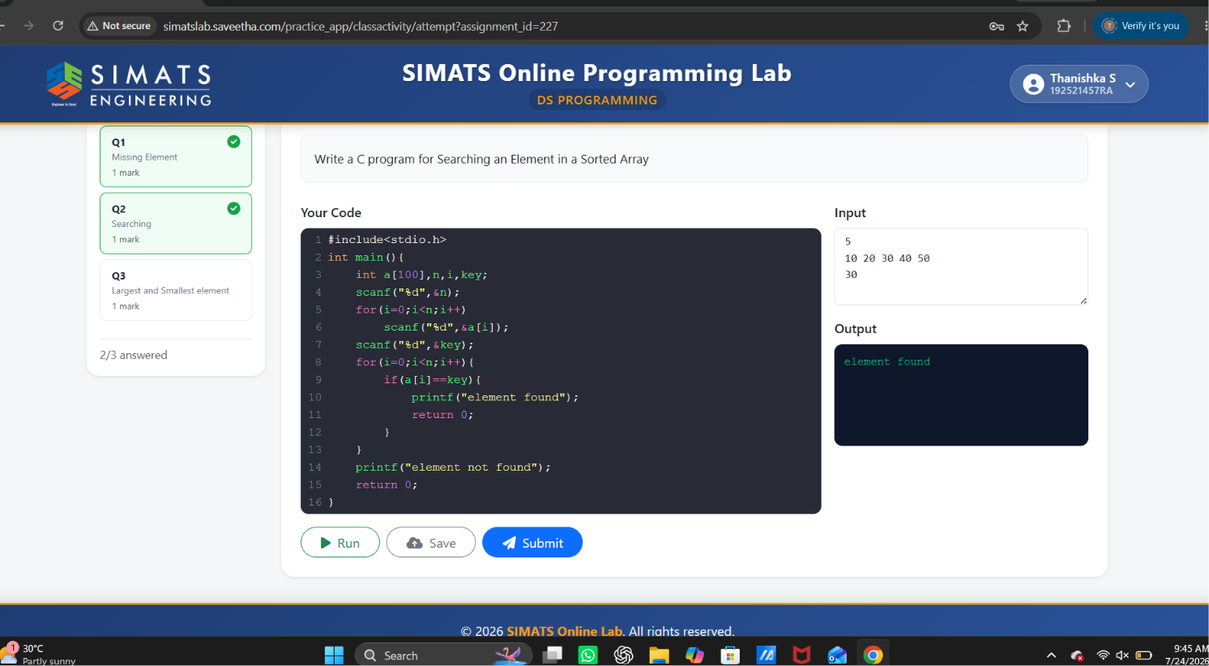

3.LARGEST AND SMALLEST ELEMENT
